SOAR-Based EDR
Endpoint Response Playbook
PROJECT DOCUMENTATION
DETAIL | INFORMATION
NAME | Afnan Qureshi
TRAINER / MENTOR | Mr.Shashidhar
COURSE | Cyber Security +Ai
ACADEMIC YEAR | 2026-27
ACADEMY | TEKS Academy
Endpoint Detection • Workflow Automation • Controlled Response

INDEX
SECTION | PAGE
1. Executive Summary | 4
2. Project Objectives | 5
3. Technologies and Components | 6
4. Overall Architecture and Data Flow | 7
5. Implementation Methodology | 8
6. Screenshot-by-Screenshot Project Documentation | 9–34
7. End-to-End Playbook Explanation | 35
8. Key Features of the Project | 36
9. Benefits | 37
10. Testing and Validation | 38
11. Limitations and Practical Considerations | 39
12. Future Enhancements | 40
13. Conclusion | 41
14. Appendix: Figure Reference | 42

FIGURE / DESCRIPTION | PAGE
Figure 1 – Project workspace and prepared artifacts | 9
Figure 2 – Windows endpoint test environment | 10
Figure 3 – Verifying the test executable from PowerShell | 11
Figure 4 – Executing the endpoint test activity | 12
Figure 5 – Remote access to the test endpoint | 13
Figure 6 – SOAR platform entry point | 14
Figure 7 – LimaCharlie sensor registration | 15
Figure 8 – Detection and Response Rules | 16
Figure 9 – LaZagne-focused detection rule | 17
Figure 10 – Historical scan validation | 18
Figure 11 – Configured detection rules list | 19
Figure 12 – Selecting an output stream | 20
Figure 13 – Outputs not yet connected | 21
Figure 14 – EDR output configuration | 22
Figure 15 – Detection generated by the test | 23
Figure 16 – Slack security operations channel | 24
Figure 17 – Tines story and webhook receiver | 25
Figure 18 – Webhook receives the LimaCharlie alert | 26
Figure 19 – Webhook rules and processing | 27
Figure 20 – User-prompt response workflow | 28
Figure 21 – Alert event data received by the workflow | 29
Figure 22 – Slack alert notification | 30
Figure 23 – User prompt with YES and NO branches | 31
Figure 24 – Completed conditional response workflow | 32
Figure 25 – Detailed endpoint detection record | 33
Figure 26 – Final LimaCharlie sensor verification | 34

LIST OF FIGURES

1. Executive Summary
This project demonstrates an endpoint detection and response workflow that receives a security alert through a webhook, processes the event through configured rules and integrations, and provides a controlled response path. The workflow is designed to show how an endpoint security alert can be handled systematically from the initial detection to the final response. Instead of performing an endpoint action immediately, the workflow introduces a user decision before isolation, allowing the response to be reviewed and approved before a potentially disruptive action is performed.
The practical implementation combines endpoint monitoring, webhook-based event handling, LimaCharlie integration, conditional response actions, and Slack notification. When an endpoint generates a security-related alert, the event is received through the webhook and passed through the configured workflow rules. LimaCharlie is used to provide endpoint detection and sensor information, while Slack is used as the communication channel for displaying alert and response information. This creates a connected workflow in which the alert can be monitored and processed through clearly defined stages.
A key part of the project is the user prompt that acts as a decision point in the response process. After the alert reaches the appropriate stage, the user can select either YES or NO depending on whether endpoint isolation is required. If YES is selected, the workflow proceeds to the HTTP Request isolation action, which is used to isolate the affected endpoint sensor. The result of the response action is then sent back to Slack so that the outcome can be observed. If NO is selected, the isolation action is skipped and the workflow directly sends the corresponding response to Slack. This conditional structure helps demonstrate how human approval can be incorporated into an automated security response process.
The project also provides a practical method for testing and validating each stage of the workflow. The endpoint activity, detection, webhook event, workflow processing, user decision, isolation action, and Slack notification can be reviewed individually. This makes it easier to identify configuration issues and verify whether the expected response is produced at each stage. The workflow therefore serves not only as an automation demonstration but also as a structured way to understand endpoint response operations.
Overall, the project demonstrates how endpoint alerts can be moved through detection, event processing, decision-making, response, and notification in a repeatable manner. By separating these stages and connecting them through defined integrations, the implementation provides a clear and controlled approach to endpoint incident response. The project also provides a foundation that can be extended in the future with additional response actions, threat-intelligence enrichment, severity-based decision rules, improved approval mechanisms, logging, and other security automation capabilities.

WORKFLOW AT A GLANCE
Webhook → Rules / Processing → LimaCharlie → Slack → User Prompt → YES / NO
YES → HTTP Request: Isolate Sensor → Slack
NO → Slack

2. Project Objectives
The main objective of this project is to develop and demonstrate a structured endpoint detection and response workflow for handling security events in a controlled environment. The project focuses on monitoring a Windows endpoint, detecting a security-related event, processing the detection through a predefined workflow, and performing an appropriate response action based on a user decision. Instead of directly isolating an endpoint as soon as an alert is generated, the workflow introduces a controlled decision stage that allows the user to review the situation and select whether the endpoint should be isolated.

The project also aims to demonstrate how different security and automation components can work together as part of a single response process. Endpoint monitoring is used to identify the event, while the webhook and configured rules handle the transfer and processing of detection information. LimaCharlie is used to support the endpoint response, and Slack provides a communication channel for alerts, decisions, and response results. The workflow is divided into clearly defined stages so that each part can be tested and verified independently as well as as part of the complete process.

Another important objective is to ensure that the response action remains controlled and verifiable. The user prompt acts as a decision point between detection and isolation. If the user selects YES, the workflow proceeds with the HTTP Request used for sensor isolation. If the user selects NO, the isolation step is skipped and the decision is communicated through Slack. This approach provides a clear distinction between detecting a threat, deciding on a response, executing the response, and communicating the result.

The project objectives are therefore defined as follows:

- Monitor a Windows endpoint using an endpoint sensor.
- Generate a controlled security event for testing.
- Create and validate a Detection & Response rule.
- Forward relevant detection information to a webhook.
- Process the received event using webhook rules/actions.
- Connect the workflow with LimaCharlie for endpoint response.
- Send alert and response information to Slack.
- Introduce a user prompt before endpoint isolation.
- Use a YES branch to trigger the HTTP Request used for sensor isolation.
- Use a NO branch to skip isolation and send the response to Slack.
- Verify the endpoint sensor and detection after the workflow test.
The objectives are organized around a controlled endpoint-response workflow: receive a real detection, process it through defined stages, obtain a user decision before isolation, and verify the resulting endpoint state.

3. Technologies and Components
COMPONENT | PURPOSE
Windows Endpoint | Controlled endpoint used to generate the test activity.
LimaCharlie | Endpoint monitoring, detection rules, detections, sensor visibility, and endpoint-response integration.
Webhook | Receives the alert and starts the response workflow.
Webhook Rules / Actions | Processes the received alert and routes it to the required integrations.
Tines | Visual workflow environment used to build the response sequence shown in the screenshots.
Slack | Notification and response channel for the SOC.
HTTP Request / Sensor Isolation | YES-path action used to isolate the endpoint sensor.
These components form a single response chain. The endpoint and LimaCharlie provide detection context, the webhook and workflow rules handle event movement, Slack provides operational visibility, and the HTTP Request is used on the approved YES isolation path.

4. Overall Architecture and Data Flow

The implemented response workflow follows the order below:

WEBHOOK
↓
WEBHOOK RULES / PROCESSING
↓
LIMACHARLIE
↓
SLACK RESPONSE / NOTIFICATION
↓
USER PROMPT
↓
CONDITION: YES / NO
YES → HTTP REQUEST: ISOLATE SENSOR → SLACK
NO → SLACK

WEBHOOK
↓
WEBHOOK RULES / PROCESSING
↓
LIMACHARLIE
↓
SLACK RESPONSE / NOTIFICATION
↓
USER PROMPT
↓
CONDITION: YES / NO
YES → HTTP REQUEST: ISOLATE SENSOR → SLACK
NO → SLACK
The user prompt is the decision point. Selecting YES continues to the HTTP Request used for sensor isolation and then returns the response to Slack. Selecting NO skips the isolation action and sends the NO response directly to Slack.

5. Implementation Methodology

- Endpoint preparation: Prepare the Windows endpoint and generate the controlled test activity.
- EDR detection: LimaCharlie observes the activity and creates the detection.
- Webhook: Forward the alert to the webhook.
- Webhook rules: Apply the configured rules/actions to the received alert.
- LimaCharlie connection: Connect the workflow to LimaCharlie for the endpoint-response stage.
- Slack connection: Connect Slack for alert and response notification.
- User prompt: Ask whether the endpoint should be isolated.
- YES branch: Send YES to the HTTP Request used for sensor isolation and then to Slack.
- NO branch: Send NO directly to Slack without performing isolation.
- Verification: Review the LimaCharlie detection and sensor status after the test.

The above methodology represents the complete flow of the endpoint detection and response process implemented in the project. Each stage is connected to the next so that the security event can move through detection, alert forwarding, event processing, decision-making, endpoint response, and notification in a controlled sequence. The workflow is designed to ensure that the response action is not performed independently of the detection process, but instead follows the configured rules and the user's decision.
During the implementation, each stage can be tested individually before validating the complete workflow. The endpoint preparation and detection stages confirm that the security activity is successfully identified. The webhook and rule-processing stages verify that the alert is received and handled correctly. The LimaCharlie and Slack connections then provide the required endpoint-response and communication capabilities.
The user prompt forms an important control point within the methodology. It separates the detection of an event from the execution of the isolation action. When YES is selected, the workflow proceeds to the HTTP Request used for sensor isolation and communicates the resulting response through Slack. When NO is selected, the isolation action is bypassed and the decision is sent directly to Slack. This provides two clearly defined response paths and makes the workflow easier to understand and test.

Finally, the verification stage confirms whether the detection and endpoint sensor behaved as expected after the workflow execution. Reviewing the detection and sensor status helps establish that the complete process—from the initial controlled activity to the final response—has been successfully executed. Overall, the methodology provides a structured approach for implementing, testing, and validating the endpoint response workflow while maintaining a clear separation between detection, processing, user approval, response, and notification.

Figure 1. Project workspace and prepared artifacts
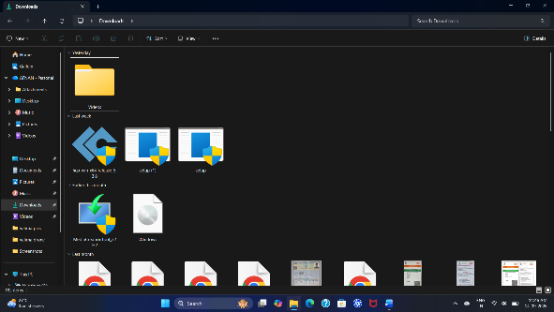
Figure 1: Project workspace and prepared artifacts
Description: The screenshot shows the Windows project workspace containing files and folders prepared for the endpoint-response lab.
Role in the Project: This is the initial project workspace used to organize the endpoint tools and supporting project files.
Technical Significance: A controlled workspace helps keep test artifacts organized and makes the practical setup easier to reproduce.
Implementation Note: The workspace establishes a controlled starting point for the lab. Keeping the endpoint tools, test artifacts, and supporting files together makes the setup easier to review and reproduce.
Validation Focus: Before detection testing begins, the required files and folders are checked so later results can be traced to a known test environment.
Connection to Next Stage: Once the workspace is prepared, the project moves to the Windows endpoint setup and controlled test activity.
Operational Interpretation: Project workspace and prepared artifacts represents a visible checkpoint in the documented response sequence. This is the initial project workspace used to organize the endpoint tools and supporting project files. A controlled workspace helps keep test artifacts organized and makes the practical setup easier to reproduce. The figure therefore provides a practical reference for understanding what the component contributes before the workflow moves forward.
Documentation Note: The screenshot records the configuration or result at this stage so that the implementation can be reviewed in the same order as the playbook. Before detection testing begins, the required files and folders are checked so later results can be traced to a known test environment. Once the workspace is prepared, the project moves to the Windows endpoint setup and controlled test activity. Keeping this relationship explicit makes the documented workflow easier to follow and reproduce during project demonstration and testing.
WHAT THE FIGURE SHOWS | WHY IT MATTERS | NEXT STEP
This is the initial project workspace used to organize the endpoint tools and supporting project files. | A controlled workspace helps keep test artifacts organized and makes the practical setup easier to reproduce. | Once the workspace is prepared, the project moves to the Windows endpoint setup and controlled test activity.

Figure 2. Windows endpoint test environment
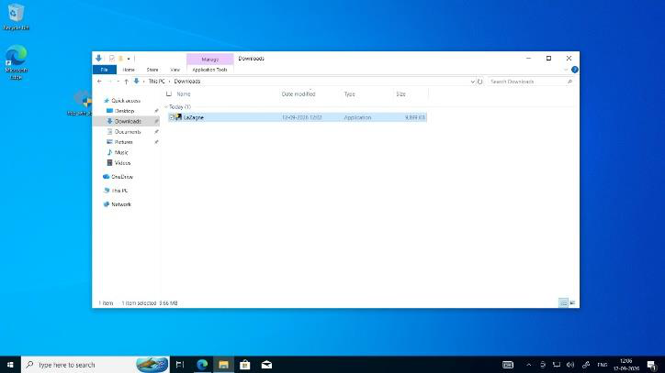
Figure 2: Windows endpoint test environment
Description: The screenshot shows the Windows endpoint with LaZagne.exe visible in the Downloads folder.
Role in the Project: The Windows machine is the monitored endpoint used to generate controlled security telemetry.
Technical Significance: The test activity provides a repeatable event that can be observed by the endpoint monitoring system.
Implementation Note: The Windows machine acts as the monitored endpoint in the lab. The visible test artifact provides the starting point for generating endpoint telemetry that can be observed by LimaCharlie.
Validation Focus: The endpoint is kept under controlled conditions so the generated activity can be correlated with the detection rule and the downstream response workflow.
Connection to Next Stage: The prepared endpoint is then checked from PowerShell before the controlled activity is executed.
Operational Interpretation: Windows endpoint test environment represents a visible checkpoint in the documented response sequence. The Windows machine is the monitored endpoint used to generate controlled security telemetry. The test activity provides a repeatable event that can be observed by the endpoint monitoring system. The figure therefore provides a practical reference for understanding what the component contributes before the workflow moves forward.
Documentation Note: The screenshot records the configuration or result at this stage so that the implementation can be reviewed in the same order as the playbook. The endpoint is kept under controlled conditions so the generated activity can be correlated with the detection rule and the downstream response workflow. The prepared endpoint is then checked from PowerShell before the controlled activity is executed. Keeping this relationship explicit makes the documented workflow easier to follow and reproduce during project demonstration and testing.
WHAT THE FIGURE SHOWS | WHY IT MATTERS | NEXT STEP
The Windows machine is the monitored endpoint used to generate controlled security telemetry. | The test activity provides a repeatable event that can be observed by the endpoint monitoring system. | The prepared endpoint is then checked from PowerShell before the controlled activity is executed.

Figure 3. Verifying the test executable from PowerShell
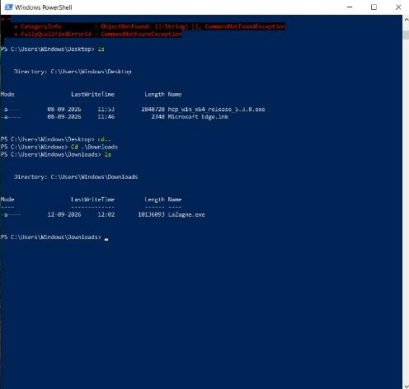
Figure 3: Verifying the test executable from PowerShell
Description: PowerShell is used to inspect the directory and confirm the presence of LaZagne.exe.
Role in the Project: This verifies that the test artifact is available before the detection scenario is executed.
Technical Significance: Command-line activity is useful endpoint telemetry because process and command-line information can support detection.
Implementation Note: PowerShell is used to confirm that the test executable is present and accessible before execution. This adds a simple pre-test verification step to the workflow.
Security Relevance: Process and command-line activity can provide useful endpoint telemetry when a rule is designed around a known test behavior.
Connection to Next Stage: After confirming the test artifact, the activity is executed so LimaCharlie can observe the resulting endpoint telemetry.
Operational Interpretation: Verifying the test executable from PowerShell represents a visible checkpoint in the documented response sequence. This verifies that the test artifact is available before the detection scenario is executed. Command-line activity is useful endpoint telemetry because process and command-line information can support detection. The figure therefore provides a practical reference for understanding what the component contributes before the workflow moves forward.
Documentation Note: The screenshot records the configuration or result at this stage so that the implementation can be reviewed in the same order as the playbook. After confirming the test artifact, the activity is executed so LimaCharlie can observe the resulting endpoint telemetry. Keeping this relationship explicit makes the documented workflow easier to follow and reproduce during project demonstration and testing.
WHAT THE FIGURE SHOWS | WHY IT MATTERS | NEXT STEP
This verifies that the test artifact is available before the detection scenario is executed. | Command-line activity is useful endpoint telemetry because process and command-line information can support detection. | After confirming the test artifact, the activity is executed so LimaCharlie can observe the resulting endpoint telemetry.

Figure 4. Executing the endpoint test activity
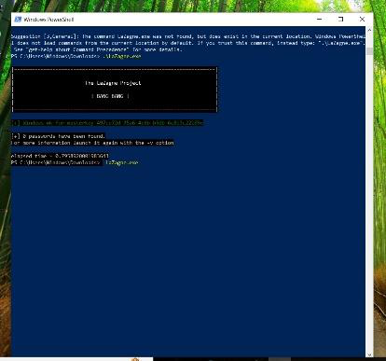
Figure 4: Executing the endpoint test activity
Description: The PowerShell window shows the LaZagne-related test activity being executed.
Role in the Project: The controlled activity is used to generate endpoint telemetry for the detection rule.
Technical Significance: The purpose of the test is to validate the detection and response workflow in an authorized lab environment.
Implementation Note: The controlled endpoint activity is executed only to validate the configured detection rule and response chain. The event is intended to create observable telemetry within the authorized lab environment.
Validation Focus: A repeatable test event makes it possible to check whether the alert is generated and subsequently reaches the webhook and response workflow.
Connection to Next Stage: The generated activity becomes the basis for detection validation and subsequent investigation in LimaCharlie.
Operational Interpretation: Executing the endpoint test activity represents a visible checkpoint in the documented response sequence. The controlled activity is used to generate endpoint telemetry for the detection rule. The purpose of the test is to validate the detection and response workflow in an authorized lab environment. The figure therefore provides a practical reference for understanding what the component contributes before the workflow moves forward.
Documentation Note: The screenshot records the configuration or result at this stage so that the implementation can be reviewed in the same order as the playbook. A repeatable test event makes it possible to check whether the alert is generated and subsequently reaches the webhook and response workflow. The generated activity becomes the basis for detection validation and subsequent investigation in LimaCharlie. Keeping this relationship explicit makes the documented workflow easier to follow and reproduce during project demonstration and testing.
WHAT THE FIGURE SHOWS | WHY IT MATTERS | NEXT STEP
The controlled activity is used to generate endpoint telemetry for the detection rule. | The purpose of the test is to validate the detection and response workflow in an authorized lab environment. | The generated activity becomes the basis for detection validation and subsequent investigation in LimaCharlie.

Figure 5. Remote access to the test endpoint
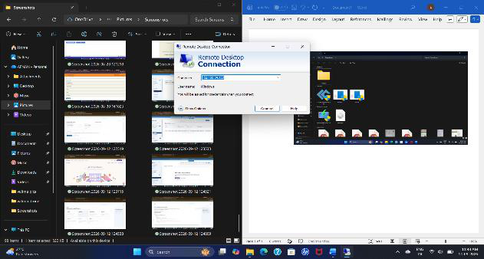
Figure 5: Remote access to the test endpoint
Description: The screenshot shows Remote Desktop Connection being used with the Windows endpoint.
Role in the Project: Remote access is used to administer and reproduce the test activity on the monitored endpoint.
Technical Significance: Remote administration is useful for demonstrating how an analyst can manage and validate a security test remotely.
Implementation Note: Remote access provides a practical way to administer the test endpoint and reproduce the same activity from the lab environment.
Validation Focus: Remote administration also demonstrates that the security test can be managed while the analyst is not physically operating the endpoint.
Connection to Next Stage: Remote administration supports the repeatable lab test and leads into the endpoint monitoring and detection configuration.
Operational Interpretation: Remote access to the test endpoint represents a visible checkpoint in the documented response sequence. Remote access is used to administer and reproduce the test activity on the monitored endpoint. Remote administration is useful for demonstrating how an analyst can manage and validate a security test remotely. The figure therefore provides a practical reference for understanding what the component contributes before the workflow moves forward.
Documentation Note: The screenshot records the configuration or result at this stage so that the implementation can be reviewed in the same order as the playbook. Remote administration also demonstrates that the security test can be managed while the analyst is not physically operating the endpoint. Remote administration supports the repeatable lab test and leads into the endpoint monitoring and detection configuration. Keeping this relationship explicit makes the documented workflow easier to follow and reproduce during project demonstration and testing.
WHAT THE FIGURE SHOWS | WHY IT MATTERS | NEXT STEP
Remote access is used to administer and reproduce the test activity on the monitored endpoint. | Remote administration is useful for demonstrating how an analyst can manage and validate a security test remotely. | Remote administration supports the repeatable lab test and leads into the endpoint monitoring and detection configuration.

Figure 6. SOAR platform entry point
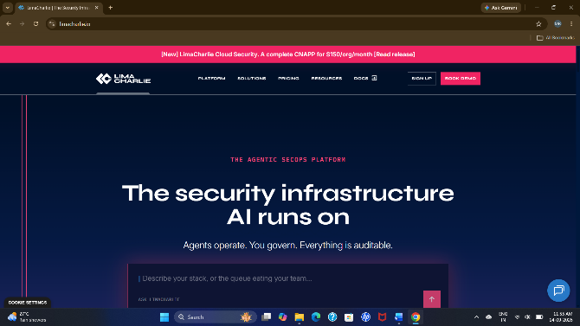
Figure 6: SOAR platform entry point
Description: The screenshot shows the LimaCharlie platform entry point.
Role in the Project: This represents the automation environment used as part of the project.
Technical Significance: The automation layer provides a visual environment for connecting security events with response actions.
Implementation Note: The LimaCharlie platform provides the endpoint-security interface used to register the sensor, configure detection rules, review detections, and inspect endpoint information.
Project Relevance: This platform forms the endpoint detection and response layer that supplies the security event used by the automation workflow.
Connection to Next Stage: After entering the platform, the next configuration step is to register and verify the endpoint sensor.
Operational Interpretation: SOAR platform entry point represents a visible checkpoint in the documented response sequence. This represents the automation environment used as part of the project. The automation layer provides a visual environment for connecting security events with response actions. The figure therefore provides a practical reference for understanding what the component contributes before the workflow moves forward.
Documentation Note: The screenshot records the configuration or result at this stage so that the implementation can be reviewed in the same order as the playbook. After entering the platform, the next configuration step is to register and verify the endpoint sensor. Keeping this relationship explicit makes the documented workflow easier to follow and reproduce during project demonstration and testing.
WHAT THE FIGURE SHOWS | WHY IT MATTERS | NEXT STEP
This represents the automation environment used as part of the project. | The automation layer provides a visual environment for connecting security events with response actions. | After entering the platform, the next configuration step is to register and verify the endpoint sensor.

Figure 7. LimaCharlie sensor registration
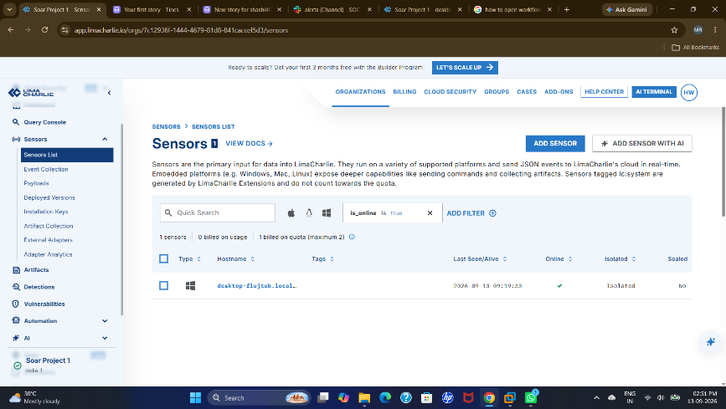
Figure 7: LimaCharlie sensor registration
Description: The LimaCharlie Sensors page shows an enrolled endpoint sensor.
Role in the Project: The sensor provides endpoint visibility and supplies telemetry to the detection layer.
Technical Significance: A working sensor is required for the detection and response workflow to receive endpoint events.
Implementation Note: The enrolled LimaCharlie sensor is the connection between the Windows endpoint and the detection layer. Its telemetry supports rule evaluation and later validation.
Validation Focus: Sensor visibility is checked before testing so that a missing or inactive sensor does not create a false indication of workflow failure.
Connection to Next Stage: With the sensor visible, the detection rules can be configured and tested against the endpoint activity.
Operational Interpretation: LimaCharlie sensor registration represents a visible checkpoint in the documented response sequence. The sensor provides endpoint visibility and supplies telemetry to the detection layer. A working sensor is required for the detection and response workflow to receive endpoint events. The figure therefore provides a practical reference for understanding what the component contributes before the workflow moves forward.
Documentation Note: The screenshot records the configuration or result at this stage so that the implementation can be reviewed in the same order as the playbook. Sensor visibility is checked before testing so that a missing or inactive sensor does not create a false indication of workflow failure. With the sensor visible, the detection rules can be configured and tested against the endpoint activity. Keeping this relationship explicit makes the documented workflow easier to follow and reproduce during project demonstration and testing.
WHAT THE FIGURE SHOWS | WHY IT MATTERS | NEXT STEP
The sensor provides endpoint visibility and supplies telemetry to the detection layer. | A working sensor is required for the detection and response workflow to receive endpoint events. | With the sensor visible, the detection rules can be configured and tested against the endpoint activity.

Figure 8. Detection and Response Rules
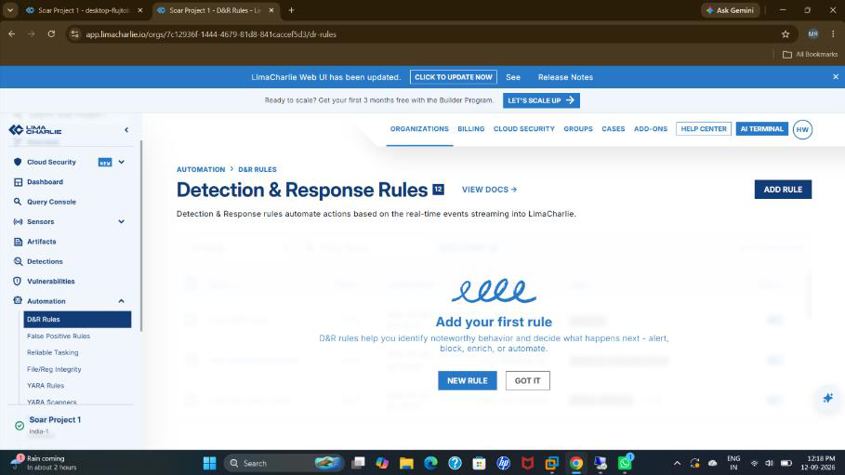
Figure 8: Detection and Response Rules
Description: The LimaCharlie Detection & Response Rules page is open.
Role in the Project: This is the EDR detection-rule configuration area used to define conditions for endpoint events.
Technical Significance: Rules convert endpoint telemetry into security-relevant detections that can be forwarded to the response workflow.
Implementation Note: The Detection & Response Rules area is used to define the conditions under which endpoint telemetry becomes a detection. The rule configuration is a central part of the detection stage.
Security Relevance: Well-defined rules reduce unnecessary workflow triggers and provide a consistent basis for forwarding relevant security events.
Connection to Next Stage: The general rule configuration is followed by the specific test rule used to recognize the selected endpoint behavior.
Operational Interpretation: Detection and Response Rules represents a visible checkpoint in the documented response sequence. This is the EDR detection-rule configuration area used to define conditions for endpoint events. Rules convert endpoint telemetry into security-relevant detections that can be forwarded to the response workflow. The figure therefore provides a practical reference for understanding what the component contributes before the workflow moves forward.
Documentation Note: The screenshot records the configuration or result at this stage so that the implementation can be reviewed in the same order as the playbook. The general rule configuration is followed by the specific test rule used to recognize the selected endpoint behavior. Keeping this relationship explicit makes the documented workflow easier to follow and reproduce during project demonstration and testing.
WHAT THE FIGURE SHOWS | WHY IT MATTERS | NEXT STEP
This is the EDR detection-rule configuration area used to define conditions for endpoint events. | Rules convert endpoint telemetry into security-relevant detections that can be forwarded to the response workflow. | The general rule configuration is followed by the specific test rule used to recognize the selected endpoint behavior.

Figure 9. LaZagne-focused detection rule
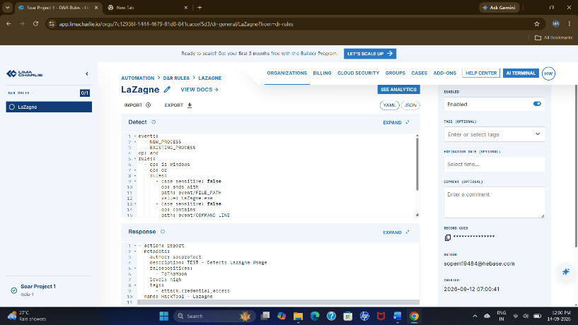
Figure 9: LaZagne-focused detection rule
Description: A Detection & Response Rule related to LaZagne is visible.
Role in the Project: The rule is configured to recognize the controlled test behavior on the endpoint.
Technical Significance: A specific test rule makes the validation process repeatable from detection through response.
Implementation Note: The LaZagne-focused rule is used as the controlled detection condition for the lab test. It gives the project a repeatable event that can be traced from endpoint activity to response.
Validation Focus: The rule is checked against the expected test behavior so the detection stage can be validated before the automation path is exercised.
Connection to Next Stage: The focused rule can then be checked using historical telemetry before the live workflow is exercised.
Operational Interpretation: LaZagne-focused detection rule represents a visible checkpoint in the documented response sequence. The rule is configured to recognize the controlled test behavior on the endpoint. A specific test rule makes the validation process repeatable from detection through response. The figure therefore provides a practical reference for understanding what the component contributes before the workflow moves forward.
Documentation Note: The screenshot records the configuration or result at this stage so that the implementation can be reviewed in the same order as the playbook. The rule is checked against the expected test behavior so the detection stage can be validated before the automation path is exercised. The focused rule can then be checked using historical telemetry before the live workflow is exercised. Keeping this relationship explicit makes the documented workflow easier to follow and reproduce during project demonstration and testing.
WHAT THE FIGURE SHOWS | WHY IT MATTERS | NEXT STEP
The rule is configured to recognize the controlled test behavior on the endpoint. | A specific test rule makes the validation process repeatable from detection through response. | The focused rule can then be checked using historical telemetry before the live workflow is exercised.

Figure 10. Historical scan validation
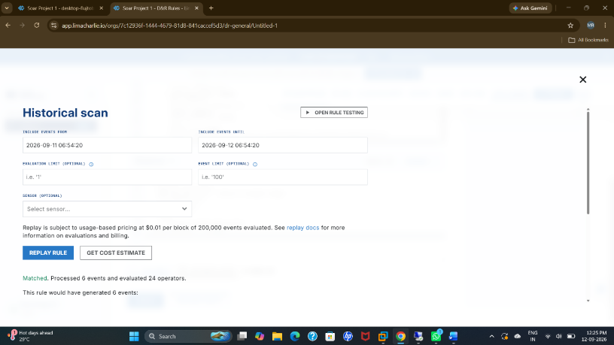
Figure 10: Historical scan validation
Description: The Historical Scan interface is shown with its time-range and scan controls.
Role in the Project: Historical scanning can be used to check previously collected telemetry against the detection condition.
Technical Significance: This supports rule validation and retrospective investigation.
Implementation Note: Historical Scan provides a way to review previously collected telemetry against the detection condition. This is useful when validating a rule after the original activity has already occurred.
Security Relevance: Retrospective validation supports rule checking and investigation by showing how the detection condition relates to previously collected endpoint data.
Connection to Next Stage: Historical validation supports confidence in the rule before reviewing the complete configured rule set and output configuration.
Operational Interpretation: Historical scan validation represents a visible checkpoint in the documented response sequence. Historical scanning can be used to check previously collected telemetry against the detection condition. This supports rule validation and retrospective investigation. The figure therefore provides a practical reference for understanding what the component contributes before the workflow moves forward.
Documentation Note: The screenshot records the configuration or result at this stage so that the implementation can be reviewed in the same order as the playbook. Historical validation supports confidence in the rule before reviewing the complete configured rule set and output configuration. Keeping this relationship explicit makes the documented workflow easier to follow and reproduce during project demonstration and testing.
WHAT THE FIGURE SHOWS | WHY IT MATTERS | NEXT STEP
Historical scanning can be used to check previously collected telemetry against the detection condition. | This supports rule validation and retrospective investigation. | Historical validation supports confidence in the rule before reviewing the complete configured rule set and output configuration.

Figure 11. Configured detection rules list
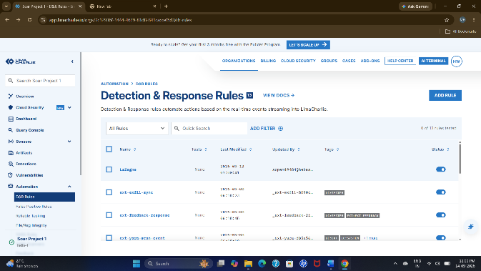
Figure 11: Configured detection rules list
Description: The Detection & Response Rules list shows configured rules and their states.
Role in the Project: This provides an overview of the detection rules available for endpoint monitoring.
Technical Significance: The rule list makes the detection layer easier to review, test, and maintain.
Implementation Note: The configured-rules list provides an overview of the active detection logic. Reviewing this list helps confirm that the intended rule is available and enabled for the endpoint workflow.
Maintenance Value: A visible rule inventory makes the detection layer easier to review, troubleshoot, and maintain as additional endpoint behaviors are added.
Connection to Next Stage: After confirming the rule set, the required output stream is selected so detections can be forwarded to the workflow.
Operational Interpretation: Configured detection rules list represents a visible checkpoint in the documented response sequence. This provides an overview of the detection rules available for endpoint monitoring. The rule list makes the detection layer easier to review, test, and maintain. The figure therefore provides a practical reference for understanding what the component contributes before the workflow moves forward.
Documentation Note: The screenshot records the configuration or result at this stage so that the implementation can be reviewed in the same order as the playbook. After confirming the rule set, the required output stream is selected so detections can be forwarded to the workflow. Keeping this relationship explicit makes the documented workflow easier to follow and reproduce during project demonstration and testing.
WHAT THE FIGURE SHOWS | WHY IT MATTERS | NEXT STEP
This provides an overview of the detection rules available for endpoint monitoring. | The rule list makes the detection layer easier to review, test, and maintain. | After confirming the rule set, the required output stream is selected so detections can be forwarded to the workflow.

Figure 12. Selecting an output stream
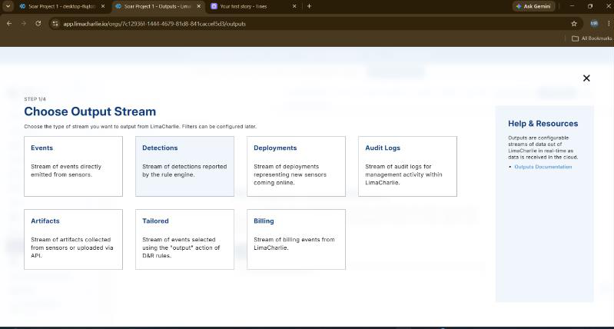
Figure 12: Selecting an output stream
Description: The interface shows output-stream categories including Events, Detections, Deployments, Audit Log, Artifacts, Tailored, and Billing.
Role in the Project: The required output type is selected so relevant detection information can be forwarded to the automation workflow.
Technical Significance: Structured output allows downstream workflow actions to process useful detection information.
Implementation Note: The output-stream selection determines which category of LimaCharlie information is forwarded to the automation layer. Selecting the relevant stream keeps downstream processing focused on useful event data.
Integration Value: Structured output is important because the webhook and later workflow steps need usable event fields rather than only a visual alert.
Connection to Next Stage: The selected stream is followed by output-connection configuration, which determines whether detection data can leave the EDR layer.
Operational Interpretation: Selecting an output stream represents a visible checkpoint in the documented response sequence. The required output type is selected so relevant detection information can be forwarded to the automation workflow. Structured output allows downstream workflow actions to process useful detection information. The figure therefore provides a practical reference for understanding what the component contributes before the workflow moves forward.
Documentation Note: The screenshot records the configuration or result at this stage so that the implementation can be reviewed in the same order as the playbook. The selected stream is followed by output-connection configuration, which determines whether detection data can leave the EDR layer. Keeping this relationship explicit makes the documented workflow easier to follow and reproduce during project demonstration and testing.
WHAT THE FIGURE SHOWS | WHY IT MATTERS | NEXT STEP
The required output type is selected so relevant detection information can be forwarded to the automation workflow. | Structured output allows downstream workflow actions to process useful detection information. | The selected stream is followed by output-connection configuration, which determines whether detection data can leave the EDR layer.

Figure 13. Outputs not yet connected
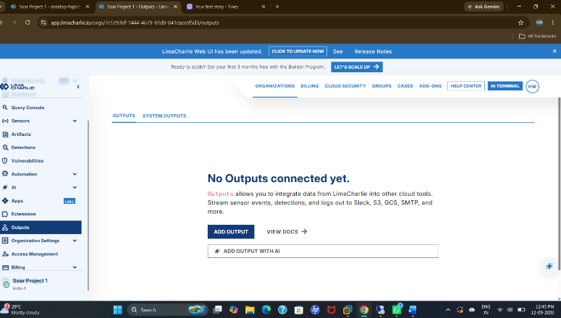
Figure 13: Outputs not yet connected
Description: The Outputs page shows that no outputs are connected at this stage.
Role in the Project: This represents the configuration checkpoint before the EDR output is connected.
Technical Significance: It is useful for troubleshooting because a missing output can prevent detections from reaching the automation workflow.
Implementation Note: The unconnected-output state represents a configuration checkpoint. At this stage, the detection platform has not yet been linked to the downstream workflow through the required output.
Troubleshooting Value: Checking this state helps isolate integration problems because a valid detection may not reach the webhook until the required output is connected.
Connection to Next Stage: The output is then connected and configured so the generated detection can be delivered to the response workflow.
Operational Interpretation: Outputs not yet connected represents a visible checkpoint in the documented response sequence. This represents the configuration checkpoint before the EDR output is connected. It is useful for troubleshooting because a missing output can prevent detections from reaching the automation workflow. The figure therefore provides a practical reference for understanding what the component contributes before the workflow moves forward.
Documentation Note: The screenshot records the configuration or result at this stage so that the implementation can be reviewed in the same order as the playbook. The output is then connected and configured so the generated detection can be delivered to the response workflow. Keeping this relationship explicit makes the documented workflow easier to follow and reproduce during project demonstration and testing.
WHAT THE FIGURE SHOWS | WHY IT MATTERS | NEXT STEP
This represents the configuration checkpoint before the EDR output is connected. | It is useful for troubleshooting because a missing output can prevent detections from reaching the automation workflow. | The output is then connected and configured so the generated detection can be delivered to the response workflow.

Figure 14. EDR output configuration
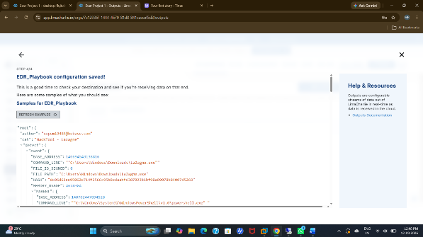
Figure 14: EDR output configuration
Description: The screenshot shows the EDR_Playbook output configuration and structured event information.
Role in the Project: The output is configured to forward detection information to the next stage of the workflow.
Technical Significance: Structured event data allows the workflow to use detection fields when processing the alert.
Implementation Note: The EDR_Playbook output is configured to carry structured detection information toward the response workflow. The configuration connects the detection layer with the automation entry point.
Integration Value: The forwarded event preserves useful detection fields so the workflow can process the alert and retain its endpoint context.
Connection to Next Stage: Once the EDR output is configured, a test event can confirm that LimaCharlie generates a detection for the workflow.
Operational Interpretation: EDR output configuration represents a visible checkpoint in the documented response sequence. The output is configured to forward detection information to the next stage of the workflow. Structured event data allows the workflow to use detection fields when processing the alert. The figure therefore provides a practical reference for understanding what the component contributes before the workflow moves forward.
Documentation Note: The screenshot records the configuration or result at this stage so that the implementation can be reviewed in the same order as the playbook. Once the EDR output is configured, a test event can confirm that LimaCharlie generates a detection for the workflow. Keeping this relationship explicit makes the documented workflow easier to follow and reproduce during project demonstration and testing.
WHAT THE FIGURE SHOWS | WHY IT MATTERS | NEXT STEP
The output is configured to forward detection information to the next stage of the workflow. | Structured event data allows the workflow to use detection fields when processing the alert. | Once the EDR output is configured, a test event can confirm that LimaCharlie generates a detection for the workflow.

Figure 15. Detection generated by the test
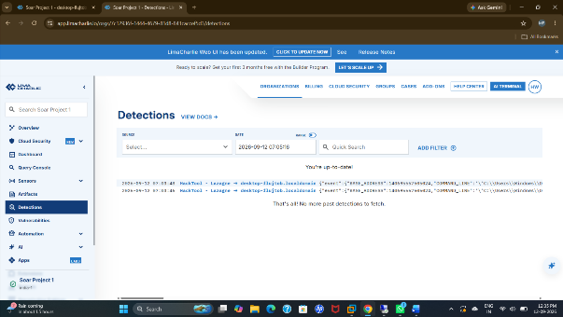
Figure 15: Detection generated by the test
Description: The LimaCharlie Detections page shows a recorded detection event.
Role in the Project: This confirms that the controlled endpoint activity has been converted into an EDR detection.
Technical Significance: This is a key validation point between endpoint activity and the automated response workflow.
Implementation Note: The recorded detection confirms that the controlled endpoint activity was recognized by LimaCharlie. This is the handoff point between endpoint telemetry and the automated response process.
Validation Focus: A successful detection is required before testing the webhook, conditional decision, isolation request, and Slack notification stages.
Connection to Next Stage: The generated detection provides the event that is communicated through the security operations channel and then forwarded into the automation flow.
Operational Interpretation: Detection generated by the test represents a visible checkpoint in the documented response sequence. This confirms that the controlled endpoint activity has been converted into an EDR detection. This is a key validation point between endpoint activity and the automated response workflow. The figure therefore provides a practical reference for understanding what the component contributes before the workflow moves forward.
Documentation Note: The screenshot records the configuration or result at this stage so that the implementation can be reviewed in the same order as the playbook. A successful detection is required before testing the webhook, conditional decision, isolation request, and Slack notification stages. The generated detection provides the event that is communicated through the security operations channel and then forwarded into the automation flow. Keeping this relationship explicit makes the documented workflow easier to follow and reproduce during project demonstration and testing.
WHAT THE FIGURE SHOWS | WHY IT MATTERS | NEXT STEP
This confirms that the controlled endpoint activity has been converted into an EDR detection. | This is a key validation point between endpoint activity and the automated response workflow. | The generated detection provides the event that is communicated through the security operations channel and then forwarded into the automation flow.

Figure 16. Slack security operations channel
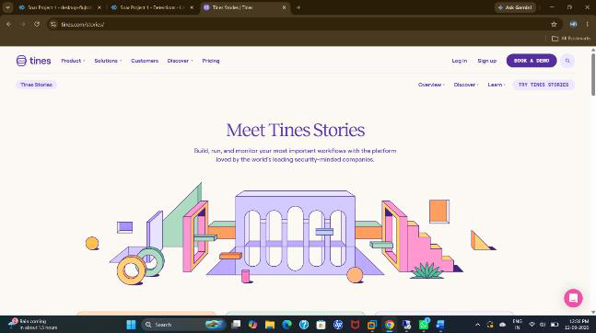
Figure 16: Slack security operations channel
Description: The screenshot shows a Slack workspace with a security-oriented channel.
Role in the Project: Slack is used as the response and notification destination for the workflow.
Technical Significance: A shared notification channel gives the SOC immediate visibility of security events and response results.
Implementation Note: Slack is used as the security operations communication channel. Alert and response messages provide a visible record for the analyst or SOC workflow.
Operational Value: Centralized notification makes it easier to review the event, observe the selected response, and communicate the outcome.
Connection to Next Stage: After notification visibility is established, the Tines workflow and its webhook receiver can accept the incoming event.
Operational Interpretation: Slack security operations channel represents a visible checkpoint in the documented response sequence. Slack is used as the response and notification destination for the workflow. A shared notification channel gives the SOC immediate visibility of security events and response results. The figure therefore provides a practical reference for understanding what the component contributes before the workflow moves forward.
Documentation Note: The screenshot records the configuration or result at this stage so that the implementation can be reviewed in the same order as the playbook. After notification visibility is established, the Tines workflow and its webhook receiver can accept the incoming event. Keeping this relationship explicit makes the documented workflow easier to follow and reproduce during project demonstration and testing.
WHAT THE FIGURE SHOWS | WHY IT MATTERS | NEXT STEP
Slack is used as the response and notification destination for the workflow. | A shared notification channel gives the SOC immediate visibility of security events and response results. | After notification visibility is established, the Tines workflow and its webhook receiver can accept the incoming event.

Figure 17. Tines story and webhook receiver
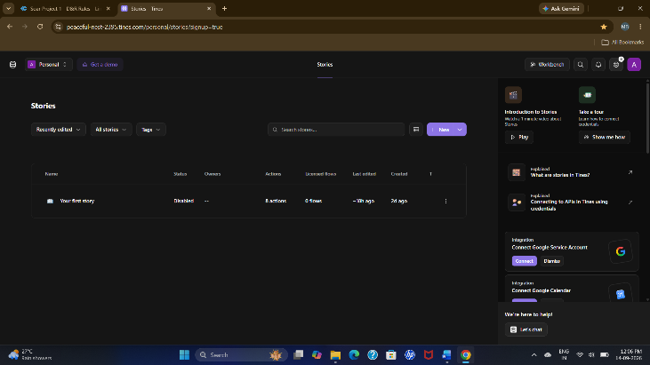
Figure 17: Tines story and webhook receiver
Description: The Tines story builder shows the Webhook Item used to receive structured event information.
Role in the Project: The webhook is the entry point of the response workflow. It receives the LimaCharlie alert and passes the event into the configured workflow.
Technical Significance: The webhook provides the connection between the incoming detection and the response logic.
Implementation Note: The Tines story contains the webhook receiver that starts the workflow. It provides the automation structure used to connect event reception with processing and response actions.
Workflow Value: Starting with a webhook keeps the playbook event-driven: a received detection can enter the configured sequence without manual copying of alert data.
Connection to Next Stage: The webhook becomes the first automation stage, receiving the structured LimaCharlie alert and passing it into processing.
Operational Interpretation: Tines story and webhook receiver represents a visible checkpoint in the documented response sequence. The webhook is the entry point of the response workflow. It receives the LimaCharlie alert and passes the event into the configured workflow. The webhook provides the connection between the incoming detection and the response logic. The figure therefore provides a practical reference for understanding what the component contributes before the workflow moves forward.
Documentation Note: The screenshot records the configuration or result at this stage so that the implementation can be reviewed in the same order as the playbook. The webhook becomes the first automation stage, receiving the structured LimaCharlie alert and passing it into processing. Keeping this relationship explicit makes the documented workflow easier to follow and reproduce during project demonstration and testing.
WHAT THE FIGURE SHOWS | WHY IT MATTERS | NEXT STEP
The webhook is the entry point of the response workflow. It receives the LimaCharlie alert and passes the event into the configured workflow. | The webhook provides the connection between the incoming detection and the response logic. | The webhook becomes the first automation stage, receiving the structured LimaCharlie alert and passing it into processing.

Figure 18. Webhook receives the LimaCharlie alert
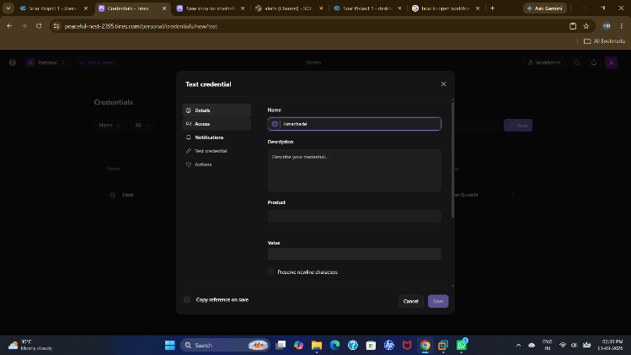
Figure 18: Webhook receives the LimaCharlie alert
Description: The workflow shows the Webhook Item receiving LimaCharlie alert data.
Role in the Project: After the webhook receives the event, the configured webhook rules/actions process the incoming alert.
Technical Significance: This stage starts the automated response sequence from the received detection.
Implementation Note: The webhook receives the LimaCharlie alert as structured event data. After reception, the workflow can apply its configured rules and route the event to the required stages.
Validation Focus: Successful receipt confirms that the connection between the EDR output and the automation workflow is functioning.
Connection to Next Stage: After receipt, webhook rules and actions process the event and prepare it for the decision and response stages.
Operational Interpretation: Webhook receives the LimaCharlie alert represents a visible checkpoint in the documented response sequence. After the webhook receives the event, the configured webhook rules/actions process the incoming alert. This stage starts the automated response sequence from the received detection. The figure therefore provides a practical reference for understanding what the component contributes before the workflow moves forward.
Documentation Note: The screenshot records the configuration or result at this stage so that the implementation can be reviewed in the same order as the playbook. Successful receipt confirms that the connection between the EDR output and the automation workflow is functioning. After receipt, webhook rules and actions process the event and prepare it for the decision and response stages. Keeping this relationship explicit makes the documented workflow easier to follow and reproduce during project demonstration and testing.
WHAT THE FIGURE SHOWS | WHY IT MATTERS | NEXT STEP
After the webhook receives the event, the configured webhook rules/actions process the incoming alert. | This stage starts the automated response sequence from the received detection. | After receipt, webhook rules and actions process the event and prepare it for the decision and response stages.

Figure 19. Webhook rules and processing
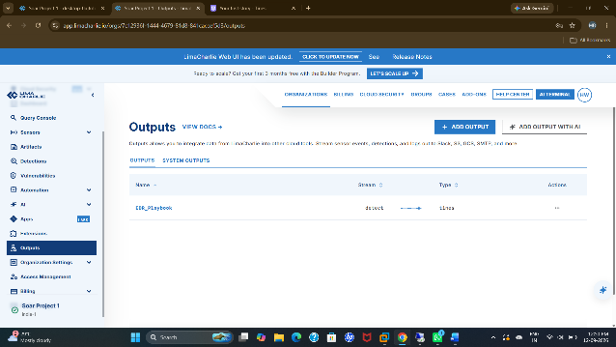
Figure 19: Webhook rules and processing
Description: The workflow is configured with actions/rules after the webhook to process the received alert.
Role in the Project: The webhook event is routed into the required processing and integration stages.
Technical Significance: This converts the received event into an actionable response workflow rather than only displaying an alert.
Implementation Note: Rules and actions placed after the webhook process the received event and prepare it for the response path. This stage separates event reception from the decisions and actions that follow.
Workflow Value: Breaking processing into explicit steps makes the playbook easier to inspect, troubleshoot, and extend with additional conditions or integrations.
Connection to Next Stage: The processed event is routed toward the user-prompt stage, where the analyst makes the endpoint-isolation decision.
Operational Interpretation: Webhook rules and processing represents a visible checkpoint in the documented response sequence. The webhook event is routed into the required processing and integration stages. This converts the received event into an actionable response workflow rather than only displaying an alert. The figure therefore provides a practical reference for understanding what the component contributes before the workflow moves forward.
Documentation Note: The screenshot records the configuration or result at this stage so that the implementation can be reviewed in the same order as the playbook. The processed event is routed toward the user-prompt stage, where the analyst makes the endpoint-isolation decision. Keeping this relationship explicit makes the documented workflow easier to follow and reproduce during project demonstration and testing.
WHAT THE FIGURE SHOWS | WHY IT MATTERS | NEXT STEP
The webhook event is routed into the required processing and integration stages. | This converts the received event into an actionable response workflow rather than only displaying an alert. | The processed event is routed toward the user-prompt stage, where the analyst makes the endpoint-isolation decision.

Figure 20. User-prompt response workflow
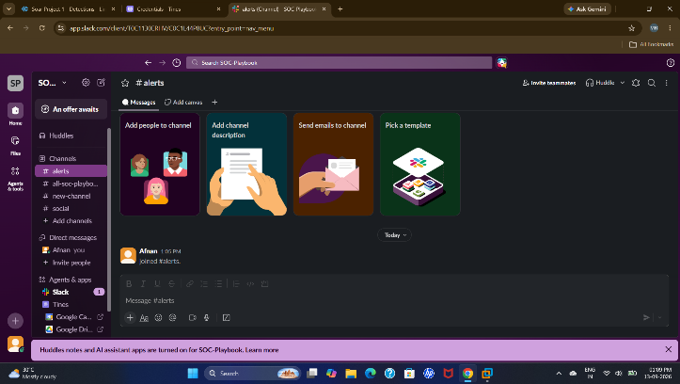
Figure 20: User-prompt response workflow
Description: The workflow contains the user-prompt stage that leads to the conditional response.
Role in the Project: The user prompt is used to obtain a decision before performing the endpoint-isolation action.
Technical Significance: The decision point provides human control before a potentially disruptive endpoint response.
Implementation Note: The user-prompt stage is placed before endpoint isolation so the workflow does not immediately perform the disruptive action. The prompt provides a deliberate analyst decision point.
Security Relevance: Human approval is useful when an alert needs verification or when isolating an endpoint could interrupt legitimate activity.
Connection to Next Stage: The prompt creates the human approval checkpoint before the workflow reaches the YES or NO response branches.
Operational Interpretation: User-prompt response workflow represents a visible checkpoint in the documented response sequence. The user prompt is used to obtain a decision before performing the endpoint-isolation action. The decision point provides human control before a potentially disruptive endpoint response. The figure therefore provides a practical reference for understanding what the component contributes before the workflow moves forward.
Documentation Note: The screenshot records the configuration or result at this stage so that the implementation can be reviewed in the same order as the playbook. The prompt creates the human approval checkpoint before the workflow reaches the YES or NO response branches. Keeping this relationship explicit makes the documented workflow easier to follow and reproduce during project demonstration and testing.
WHAT THE FIGURE SHOWS | WHY IT MATTERS | NEXT STEP
The user prompt is used to obtain a decision before performing the endpoint-isolation action. | The decision point provides human control before a potentially disruptive endpoint response. | The prompt creates the human approval checkpoint before the workflow reaches the YES or NO response branches.

Figure 21. Alert event data received by the workflow
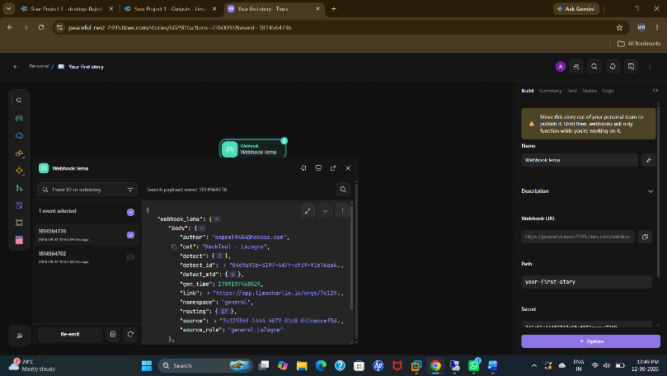
Figure 21: Alert event data received by the workflow
Description: The webhook event data is visible in the workflow and contains LimaCharlie detection information.
Role in the Project: This confirms that the alert information is available for the next workflow actions.
Technical Significance: The structured event data is used by the response workflow to determine the appropriate action.
Implementation Note: The received event data contains LimaCharlie detection information that can be passed to later workflow actions. This keeps the response connected to the original alert context.
Validation Focus: Inspecting the event payload helps confirm that the workflow received the expected fields and can use them during processing and notification.
Connection to Next Stage: The event payload supplies the information required for the downstream notification and response actions.
Operational Interpretation: Alert event data received by the workflow represents a visible checkpoint in the documented response sequence. This confirms that the alert information is available for the next workflow actions. The structured event data is used by the response workflow to determine the appropriate action. The figure therefore provides a practical reference for understanding what the component contributes before the workflow moves forward.
Documentation Note: The screenshot records the configuration or result at this stage so that the implementation can be reviewed in the same order as the playbook. Inspecting the event payload helps confirm that the workflow received the expected fields and can use them during processing and notification. The event payload supplies the information required for the downstream notification and response actions. Keeping this relationship explicit makes the documented workflow easier to follow and reproduce during project demonstration and testing.
WHAT THE FIGURE SHOWS | WHY IT MATTERS | NEXT STEP
This confirms that the alert information is available for the next workflow actions. | The structured event data is used by the response workflow to determine the appropriate action. | The event payload supplies the information required for the downstream notification and response actions.

Figure 22. Slack alert notification
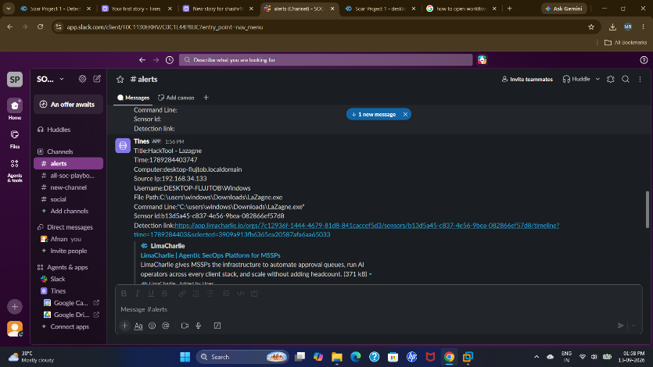
Figure 22: Slack alert notification
Description: The Slack channel displays the security alert generated by the workflow.
Role in the Project: This demonstrates that the alert/response information reaches the SOC notification channel.
Technical Significance: Slack provides immediate visibility of the event and allows analysts to coordinate the response.
Implementation Note: The Slack notification demonstrates the communication stage after the event has entered the workflow. The alert is presented in the security channel for analyst visibility.
Operational Value: The notification creates a clear handoff to the SOC and provides a visible point for reviewing the event before or after the response decision.
Connection to Next Stage: The Slack alert provides the analyst with the event context before the conditional isolation decision is applied.
Operational Interpretation: Slack alert notification represents a visible checkpoint in the documented response sequence. This demonstrates that the alert/response information reaches the SOC notification channel. Slack provides immediate visibility of the event and allows analysts to coordinate the response. The figure therefore provides a practical reference for understanding what the component contributes before the workflow moves forward.
Documentation Note: The screenshot records the configuration or result at this stage so that the implementation can be reviewed in the same order as the playbook. The Slack alert provides the analyst with the event context before the conditional isolation decision is applied. Keeping this relationship explicit makes the documented workflow easier to follow and reproduce during project demonstration and testing.
WHAT THE FIGURE SHOWS | WHY IT MATTERS | NEXT STEP
This demonstrates that the alert/response information reaches the SOC notification channel. | Slack provides immediate visibility of the event and allows analysts to coordinate the response. | The Slack alert provides the analyst with the event context before the conditional isolation decision is applied.

Figure 23. User prompt with YES and NO branches
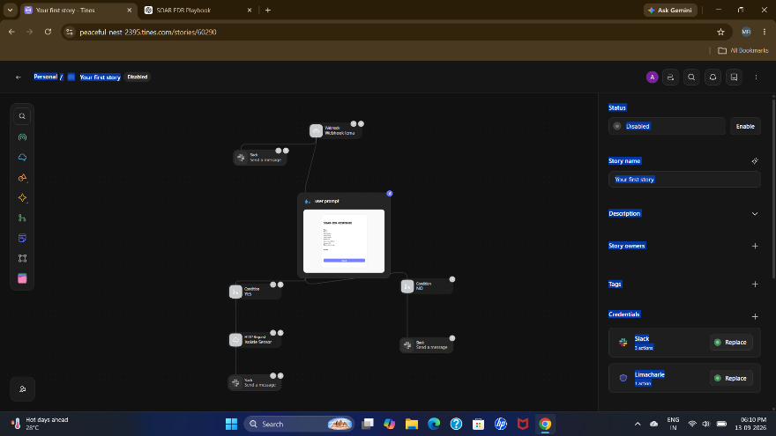
Figure 23: User prompt with YES and NO branches
Description: The workflow shows a User Prompt followed by two conditions: YES and NO.
Role in the Project: The prompt asks whether the endpoint should be isolated. YES proceeds to the HTTP Request used for sensor isolation and then to Slack. NO skips the isolation action and goes directly to the Slack response.
Technical Significance: This conditional branch is the main decision point of the endpoint-response playbook.
Implementation Note: The user prompt branches into YES and NO conditions. YES continues to the HTTP Request used for sensor isolation, while NO bypasses isolation and continues directly to Slack.
Security Relevance: This conditional design is the core control of the playbook because the endpoint action occurs only after the selected YES decision.
Connection to Next Stage: The two conditions lead to the completed response paths, with YES performing isolation and NO avoiding the isolation action.
Operational Interpretation: User prompt with YES and NO branches represents a visible checkpoint in the documented response sequence. The prompt asks whether the endpoint should be isolated. YES proceeds to the HTTP Request used for sensor isolation and then to Slack. NO skips the isolation action and goes directly to the Slack response. This conditional branch is the main decision point of the endpoint-response playbook. The figure therefore provides a practical reference for understanding what the component contributes before the workflow moves forward.
Documentation Note: The screenshot records the configuration or result at this stage so that the implementation can be reviewed in the same order as the playbook. The two conditions lead to the completed response paths, with YES performing isolation and NO avoiding the isolation action. Keeping this relationship explicit makes the documented workflow easier to follow and reproduce during project demonstration and testing.
WHAT THE FIGURE SHOWS | WHY IT MATTERS | NEXT STEP
The prompt asks whether the endpoint should be isolated. YES proceeds to the HTTP Request used for sensor isolation and then to Slack. NO skips the isolation action and goes directly to the Slack response. | This conditional branch is the main decision point of the endpoint-response playbook. | The two conditions lead to the completed response paths, with YES performing isolation and NO avoiding the isolation action.

Figure 24. Completed conditional response workflow
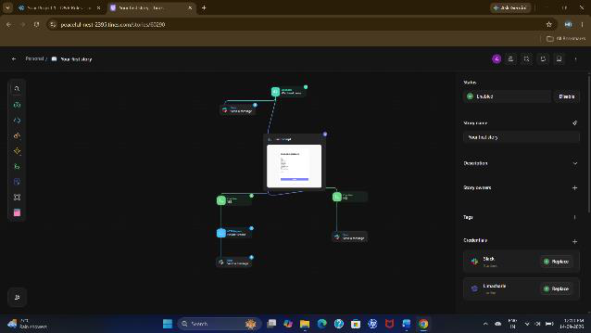
Figure 24: Completed conditional response workflow
Description: The workflow shows the connected YES and NO response paths.
Role in the Project: The YES branch goes to the HTTP Request 'Isolate Sensor' action and then to Slack. The NO branch goes directly to Slack without isolation.
Technical Significance: The design ensures that endpoint isolation occurs only when the YES decision is selected.
Implementation Note: The completed workflow connects both conditional paths to their respective outcomes. The YES path performs the isolation request and reports to Slack; the NO path reports the decision without isolation.
Validation Focus: Testing both branches confirms that the workflow behaves according to the analyst's decision and does not trigger isolation on the NO path.
Connection to Next Stage: The completed branches are then validated against the endpoint detection record and final sensor state.
Operational Interpretation: Completed conditional response workflow represents a visible checkpoint in the documented response sequence. The YES branch goes to the HTTP Request 'Isolate Sensor' action and then to Slack. The NO branch goes directly to Slack without isolation. The design ensures that endpoint isolation occurs only when the YES decision is selected. The figure therefore provides a practical reference for understanding what the component contributes before the workflow moves forward.
Documentation Note: The screenshot records the configuration or result at this stage so that the implementation can be reviewed in the same order as the playbook. Testing both branches confirms that the workflow behaves according to the analyst's decision and does not trigger isolation on the NO path. The completed branches are then validated against the endpoint detection record and final sensor state. Keeping this relationship explicit makes the documented workflow easier to follow and reproduce during project demonstration and testing.
WHAT THE FIGURE SHOWS | WHY IT MATTERS | NEXT STEP
The YES branch goes to the HTTP Request 'Isolate Sensor' action and then to Slack. The NO branch goes directly to Slack without isolation. | The design ensures that endpoint isolation occurs only when the YES decision is selected. | The completed branches are then validated against the endpoint detection record and final sensor state.

Figure 25. Detailed endpoint detection record
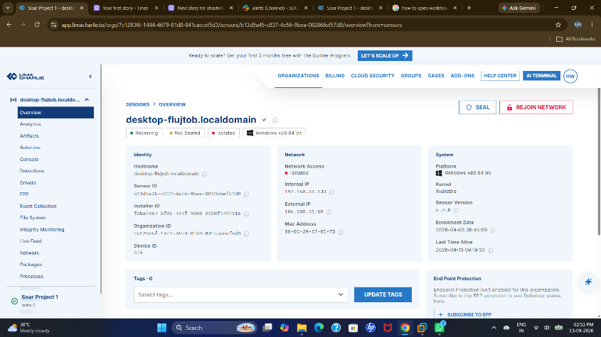
Figure 25: Detailed endpoint detection record
Description: The LimaCharlie endpoint view shows detailed information associated with the detected activity.
Role in the Project: The detection details provide evidence for investigating and validating the event that entered the workflow.
Technical Significance: The record connects the automated response process back to the original endpoint telemetry.
Implementation Note: The detailed endpoint detection record provides the underlying evidence associated with the detected activity. It allows the analyst to relate the automated response to the original endpoint event.
Investigation Value: Detailed detection information supports review of what was detected and provides context when validating the response decision.
Connection to Next Stage: Reviewing the detection record links the automated response back to the original endpoint telemetry and supports final verification.
Operational Interpretation: Detailed endpoint detection record represents a visible checkpoint in the documented response sequence. The detection details provide evidence for investigating and validating the event that entered the workflow. The record connects the automated response process back to the original endpoint telemetry. The figure therefore provides a practical reference for understanding what the component contributes before the workflow moves forward.
Documentation Note: The screenshot records the configuration or result at this stage so that the implementation can be reviewed in the same order as the playbook. Reviewing the detection record links the automated response back to the original endpoint telemetry and supports final verification. Keeping this relationship explicit makes the documented workflow easier to follow and reproduce during project demonstration and testing.
WHAT THE FIGURE SHOWS | WHY IT MATTERS | NEXT STEP
The detection details provide evidence for investigating and validating the event that entered the workflow. | The record connects the automated response process back to the original endpoint telemetry. | Reviewing the detection record links the automated response back to the original endpoint telemetry and supports final verification.

Figure 26. Final LimaCharlie sensor verification
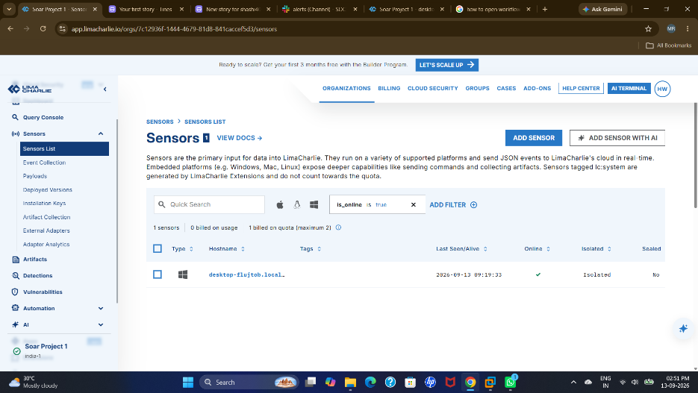
Figure 26: Final LimaCharlie sensor verification
Description: The Sensors overview shows the monitored endpoint and its sensor information.
Role in the Project: This final check confirms that the endpoint remains visible to LimaCharlie after testing the workflow.
Technical Significance: It closes the validation process by confirming continued endpoint visibility.
Implementation Note: The final sensor view is used after the workflow test to confirm that the monitored endpoint remains represented in LimaCharlie and that its sensor information can still be reviewed.
Validation Focus: This final check closes the test cycle by confirming endpoint visibility after the detection and response workflow has been exercised.
Connection to Next Stage: The final sensor check closes the documented test cycle and confirms continued endpoint visibility.
Operational Interpretation: Final LimaCharlie sensor verification represents a visible checkpoint in the documented response sequence. This final check confirms that the endpoint remains visible to LimaCharlie after testing the workflow. It closes the validation process by confirming continued endpoint visibility. The figure therefore provides a practical reference for understanding what the component contributes before the workflow moves forward.
Documentation Note: The screenshot records the configuration or result at this stage so that the implementation can be reviewed in the same order as the playbook. This final check closes the test cycle by confirming endpoint visibility after the detection and response workflow has been exercised. The final sensor check closes the documented test cycle and confirms continued endpoint visibility. Keeping this relationship explicit makes the documented workflow easier to follow and reproduce during project demonstration and testing.
WHAT THE FIGURE SHOWS | WHY IT MATTERS | NEXT STEP
This final check confirms that the endpoint remains visible to LimaCharlie after testing the workflow. | It closes the validation process by confirming continued endpoint visibility. | The final sensor check closes the documented test cycle and confirms continued endpoint visibility.

7. End-to-End Playbook Explanation

7.1 Webhook Stage
The workflow begins at the webhook, where the LimaCharlie alert is received as structured event information.

7.2 Webhook Rules and Processing
Rules/actions are applied after the webhook so the received event can be routed to the required integrations and response stages.

7.3 LimaCharlie and Slack Integration
The workflow connects with LimaCharlie for endpoint-related response and Slack for communication of the alert and response result.

7.4 User Prompt
A user prompt asks whether the endpoint should be isolated. This provides a controlled decision before the endpoint action.

7.5 YES Path
When YES is selected, the workflow sends the request to the HTTP Request action labelled for sensor isolation. After the isolation action, the response is sent to Slack.

7.6 NO Path
When NO is selected, the workflow does not perform endpoint isolation. The NO response is sent directly to Slack.

7.7 Verification
The LimaCharlie detection and sensor views are used to verify the event and endpoint status after testing.
STAGE | MAIN ACTION | DOCUMENTED OUTCOME
Webhook | Receive the LimaCharlie alert as structured event information. | Alert enters the workflow.
Rules / Processing | Apply configured rules/actions after the webhook. | Event is routed to required stages.
LimaCharlie + Slack | Use LimaCharlie for endpoint response and Slack for communication. | Endpoint context and notification are available.
User Prompt | Ask whether the endpoint should be isolated. | Human decision is captured.
YES / NO | YES continues to HTTP Request isolation; NO skips isolation. | Only the selected branch is executed.
Verification | Review detection and sensor information in LimaCharlie. | Test result and endpoint visibility are checked.

8. Key Features of the Project
- Endpoint-focused monitoring and detection.
- Rule-based processing of security alerts.
- Webhook-based integration.
- LimaCharlie endpoint-response integration.
- Slack-based alert and response communication.
- User-controlled YES/NO decision before isolation.
- HTTP Request action for the YES isolation path.
- Separate NO path that avoids isolation.
- Clear, repeatable workflow for testing and demonstration.
The feature set keeps the response process explicit: alert reception, rule-based processing, endpoint-response integration, analyst decision, conditional isolation, and final notification. This makes the playbook easier to demonstrate and validate.
FEATURE | IMPLEMENTATION VALUE
Endpoint-focused monitoring and detection | Keeps this part of the response workflow explicit, repeatable, and easy to validate.
Rule-based processing of security alerts | Keeps this part of the response workflow explicit, repeatable, and easy to validate.
Webhook-based integration | Keeps this part of the response workflow explicit, repeatable, and easy to validate.
LimaCharlie endpoint-response integration | Keeps this part of the response workflow explicit, repeatable, and easy to validate.
Slack-based alert and response communication | Keeps this part of the response workflow explicit, repeatable, and easy to validate.
User-controlled YES/NO decision before isolation | Keeps this part of the response workflow explicit, repeatable, and easy to validate.
HTTP Request action for the YES isolation path | Keeps this part of the response workflow explicit, repeatable, and easy to validate.
Separate NO path that avoids isolation | Keeps this part of the response workflow explicit, repeatable, and easy to validate.
Clear, repeatable workflow for testing and demonstration | Keeps this part of the response workflow explicit, repeatable, and easy to validate.

9. Benefits
BENEFIT | PROJECT VALUE
Reduced manual effort | Automates repetitive alert routing and notification steps.
Controlled response | The user prompt prevents isolation from occurring without the selected YES decision.
Faster communication | Slack receives the alert and response information through the workflow.
Consistency | The same response sequence can be repeated for similar detections.
Visibility | LimaCharlie provides endpoint detection and sensor information for validation.
Extensibility | Additional rules, response actions, and notification channels can be added later.
Together, these benefits show how the workflow can reduce repetitive manual handling while retaining a deliberate human checkpoint before a disruptive endpoint action.
WORKFLOW AREA | VALUE DELIVERED
Alert routing | Moves relevant alert information through defined workflow stages.
Human decision | Keeps the isolation action behind an explicit YES/NO checkpoint.
Endpoint response | Uses the HTTP Request only on the approved YES path.
Communication | Provides visible alert and response information through Slack.
Validation | Uses LimaCharlie detection and sensor information for final review.

10. Testing and Validation
- Endpoint test: Controlled activity was generated on the Windows endpoint.
- Sensor test: The LimaCharlie sensor was visible and enrolled.
- Rule test: The Detection & Response rule was configured and validated.
- Detection test: The test activity generated an EDR detection.
- Webhook test: The alert was received by the webhook.
- Workflow test: The webhook event was processed through the configured workflow.
- YES-path test: YES routed the workflow to the HTTP Request for sensor isolation and then to Slack.
- NO-path test: NO skipped isolation and routed the response directly to Slack.
- Notification test: Slack displayed the alert/response information.
- Final verification: LimaCharlie detection and sensor information were reviewed.
Validation is performed stage by stage so failures can be isolated. The endpoint event must produce a LimaCharlie detection, the detection must reach the webhook, the workflow must process it, and the selected YES or NO path must produce the expected Slack outcome.
TEST | EXPECTED CHECK | EVIDENCE / REVIEW
Endpoint test | Controlled activity is generated. | Windows endpoint activity.
Sensor test | Sensor is visible and enrolled. | LimaCharlie Sensors view.
Rule test | Detection & Response rule is configured. | Configured rule view.
Detection test | Test activity creates a detection. | LimaCharlie Detections view.
Webhook test | Alert reaches the webhook. | Received workflow event.
Workflow test | Webhook event is processed. | Configured workflow path.
YES-path test | YES reaches HTTP Request isolation and then Slack. | Response branch and notification.
NO-path test | NO skips isolation and reaches Slack. | NO branch and notification.
Notification test | Slack displays alert/response information. | Security operations channel.
Final verification | Detection and sensor state are reviewed. | LimaCharlie final check.

11. Limitations and Practical Considerations
- The project is demonstrated in a controlled lab environment and should be used only on authorized endpoints.
- Endpoint isolation is a disruptive action and should be protected by appropriate access controls and approval in a production environment.
- The screenshots demonstrate the configured workflow; production deployment would require stronger secret management, logging, failure handling, and access controls.
- Additional testing would be useful to measure detection time, response time, false positives, and workflow failure scenarios.
The documented implementation is a controlled demonstration. Production use would require organization-specific access control, secret handling, approval procedures, audit logging, and failure-recovery mechanisms around the same core workflow.
CONSIDERATION | PRACTICAL CONTROL
Controlled lab scope | Use the documented workflow only on authorized endpoints.
Disruptive isolation action | Protect endpoint isolation with appropriate access controls and approval in production.
Secrets and access | Use stronger secret management and access controls for production deployment.
Logging and failures | Add audit logging, failure handling, and recovery paths.
Performance measurement | Measure detection time, response time, false positives, and workflow failures.

12. Future Enhancements
- Add severity-based routing for different classes of endpoint alerts.
- Add analyst approval and authentication controls before isolation.
- Add automated case or ticket creation.
- Add threat-intelligence enrichment before the response decision.
- Add retry and failure-handling paths for webhook and notification failures.
- Collect and report detection-to-response timing.
- Extend the playbook to additional endpoint behaviors and response actions.
These enhancements can be added without changing the core decision structure. The existing webhook-to-response sequence provides a practical base for enrichment, approval, timing measurement, stronger failure handling, and additional endpoint actions.
ENHANCEMENT | PURPOSE
Severity-based routing | Route different classes of endpoint alerts according to severity.
Analyst approval | Add approval and authentication controls before isolation.
Case / ticket creation | Create a structured record for the incident workflow.
Threat-intelligence enrichment | Add enrichment before the response decision.
Retry and failure handling | Improve resilience when webhook or notification steps fail.
Timing metrics | Collect detection-to-response timing.
Additional endpoint actions | Extend the playbook to more endpoint behaviors and response actions.

13. Conclusion
The SOAR-Based EDR Endpoint Response Playbook demonstrates a practical and controlled approach to handling endpoint security alerts through a structured response workflow. The process begins when the webhook receives the alert generated from the endpoint monitoring environment. The alert information is then processed through the configured workflow, with LimaCharlie providing endpoint detection and response capabilities and Slack being used for security notifications and communication.
A key feature of the implementation is the inclusion of a user approval step before performing endpoint isolation. This provides a balance between automation and human decision-making. When the user selects YES, the workflow sends an HTTP Request to perform the sensor isolation action and then communicates the result through Slack. When NO is selected, the isolation action is skipped and the decision is directly reported through Slack. This conditional approach helps prevent unnecessary isolation when an alert requires further verification or when immediate containment is not appropriate.
The implementation also provides a clear separation between alert reception, event processing, decision-making, endpoint response, and notification. By dividing the response process into these stages, the workflow becomes easier to understand, test, troubleshoot, and maintain. It also provides a structured foundation for handling similar endpoint security incidents without requiring every response step to be performed manually.
Another important aspect of the playbook is its ability to support controlled automation rather than completely removing human involvement. The user prompt acts as a checkpoint where an analyst can evaluate the alert and decide whether containment should take place. This reduces the possibility of performing an unwanted response action while still allowing the system to react quickly when isolation is approved.
Overall, the project shows how endpoint detection, workflow-based automation, conditional decision-making, endpoint isolation, and security communication can be connected into a single response process. The current implementation can also serve as a foundation for future improvements, such as adding more response actions, integrating additional security tools, improving alert prioritization, and introducing more detailed logging and response tracking. Thus, the developed playbook provides a practical starting point for building more consistent, controlled, and extensible endpoint incident-response workflows.

14. Appendix: Figure Reference
FIGURE / DESCRIPTION | PAGE
Figure 1 – Project workspace and prepared artifacts | 9
Figure 2 – Windows endpoint test environment | 10
Figure 3 – Verifying the test executable from PowerShell | 11
Figure 4 – Executing the endpoint test activity | 12
Figure 5 – Remote access to the test endpoint | 13
Figure 6 – SOAR platform entry point | 14
Figure 7 – LimaCharlie sensor registration | 15
Figure 8 – Detection and Response Rules | 16
Figure 9 – LaZagne-focused detection rule | 17
Figure 10 – Historical scan validation | 18
Figure 11 – Configured detection rules list | 19
Figure 12 – Selecting an output stream | 20
Figure 13 – Outputs not yet connected | 21
Figure 14 – EDR output configuration | 22
Figure 15 – Detection generated by the test | 23
Figure 16 – Slack security operations channel | 24
Figure 17 – Tines story and webhook receiver | 25
Figure 18 – Webhook receives the LimaCharlie alert | 26
Figure 19 – Webhook rules and processing | 27
Figure 20 – User-prompt response workflow | 28
Figure 21 – Alert event data received by the workflow | 29
Figure 22 – Slack alert notification | 30
Figure 23 – User prompt with YES and NO branches | 31
Figure 24 – Completed conditional response workflow | 32
Figure 25 – Detailed endpoint detection record | 33
Figure 26 – Final LimaCharlie sensor verification | 34

